

**Redeeming an unforgiving world**

Speech given by

Mark Carney, Governor of the Bank of England

8th Annual Institute of International Finance G20 conference, Shanghai Friday 26 February 2016

The global economy risks becoming trapped in a low growth, low inflation, low interest rate equilibrium.

For the past seven years, growth has serially disappointed—sometimes spectacularly, as in the depths of the global financial and euro crises; more often than not grindingly as past debts weigh on activity (**Chart 1**).

This underperformance is principally the product of weaker potential supply growth in virtually all G20 economies.1 It is a reminder that demand stimulus on its own can do little to counteract longer-term forces of demographic change and productivity growth.

# Chart 1: Serial growth disappointments

Actual GDP growth 2011 2012 2013 2014 2015 Per cent

8

*Dotted lines = Emerging economies Solid lines = Advanced economies*

7

6

5

4

3

2

1

0

2010 2011 2012 2013 2014 2015

Source: IMF

That is not to suggest that such stimulus is without value or impact. Accommodative monetary policy can support activity while parts of the economy delever. Monetary stimulus can avoid hysteresis in the labour market. And monetary stimulus can buy time for structural adjustments which shift activity from public to private, external to domestic, and declining to rising sectors.

The time purchased by stimulus has been well spent fixing the fault lines which caused the global financial crisis. Derivative markets have been made simpler and safer. Fragile shadow banking activities are being transformed into stronger market-based finance. And the scourge of too-big-to-fail is ending.2

Most notably, a more resilient global banking system is being built. The dog that hasn’t barked in recent months has been financial distress at the core. This means banks are poised to dampen rather than amplify the impact on households and businesses of recent global financial shocks.

1 The IMF has downgraded their growth forecast for the fifth consecutive year; and now expects global growth to be around 3 ½% in 2016 and 2017. In part, this reflects a reduction in the IMF’s assessment of global potential growth to below the around 4% average growth rate in the decade prior to the crisis. At the Bank of England, our protections are slightly weaker still. We expect PPP-weighted global growth this year to be just 3.0%, a quarter of a point lower than our estimate for 2015.

2 With domestic and European legislation on resolution powers and on structural reforms in place and with a global approach to bail-in debt now agreed, the broad elements of the framework are settled. The principal challenge now is to implement.

Monetary stimulus has also made room for the repair – if not yet the completion – of European Monetary Union. Over the past year, euro-area growth has broadened, though in the ECB’s judgment, it has not yet strengthened to a degree consistent with its price stability objective let alone the expectations of Europe’s citizens.

More fundamentally, global growth has disappointed because the innovation and ambition of global monetary policy has not been matched by structural measures.

In most advanced economies, difficult structural reforms have been deferred. In parallel, in a number of emerging market economies, the post-crisis period was marked by credit booms reinforced by foreign capital inflows, which are now brutally reversing (**Charts 2** and **3**). The international financial and monetary architecture has been tinkered with rather than transformed. With the forces of fragmentation now rising in many countries, it will be more challenging to build a truly open, global system. The consequences of such timidity are reflected in the sizeable downside risks which currently plague the global outlook.

# Chart 2: Credit booms across EMEs

Percentage points

80



2008 Q2

2014 Q1

2015 Q1

+

-

60

40

20

0

20

40

60

Ireland

Spain

United Kingdom

United States

Hungary

India

South Africa

Poland

Argentina

South Korea

Mexico

Russia

Indonesia

Brazil

Turkey

Singapore

China

Hong Kong

Sources: BIS *total credit statistics* and Bank calculations.

# Chart 3: EME capital flows reversing

Per cent of GDP

5

EM ex. China

China

(a)

4

3

2

1

+

0

-

-1

-2

-3

-4

2000 2002 2004 2006 2008 2010 2012 2014 2016

Source: IMF

(a) 2016 is a forecast.

These shortcomings also explain much of the sharp fall in global nominal growth since the crisis. Since 2007, global nominal GDP growth (in dollars) has been cut in half from over 8% to 4% last year, thereby compounding the challenges of private and public deleveraging (**Table 1**). In an unforgiving global environment even those economies with resilient private demand, like the UK, must manage policy with vigilance and dexterity.

# Table 1: Global nominal growth halved since 2007

|  |  |  |  |  |  |  |
| --- | --- | --- | --- | --- | --- | --- |
| **%** | **China** | **US** | **Euro area** | **UK** | **Japan** | **World** |
| 1998-2007  average | 13.0 | 5.3 | 4.4 | 5.3 | -0.2 | 6.5 |
| 2007 | 23.1 | 4.5 | 5.6 | 5.5 | 1.2 | 8.4 |
| 2013 | 10.1 | 3.1 | 1.0 | 4.2 | 0.8 | 4.9 |
| 2014 | 8.2 | 4.1 | 1.8 | 4.7 | 1.6 | 5.0 |
| 2015 (estimate) | 6.5 | 3.4 | 2.8 | 2.6 | 2.5 | 4.0 |

Source: IMF and Bank calculations.

Renewed appreciation of the weak global outlook appears to have been the underlying cause of recent market turbulence. The latest freefall in commodity prices – though largely the product of actual and

potential supply increases – has reinforced concerns about the sluggishness of global demand. And a series of relatively small data disappointments for many major G20 economies have added to these worries.

Necessary changes in the stance of monetary policy removed the complacent assumption that “all bad news is good news” (because it brought renewed stimulus) that many felt underpinned markets.

And as I will discuss in a moment, several commentators are peddling the myth that monetary policy is “out of ammunition.” Is “the only game in town” over?

As a consequence of these developments, investors are now re-considering whether the past seven years have been well spent. Has exceptional monetary policy merely bridged two low-growth equilibria? Or, even worse, has it been a pier, leaving the global economy facing a global liquidity trap? Can more time be purchased? If so, at what cost and, most importantly, how would that time be best spent?

These are the questions we should address during China’s G20 Presidency. They must be met with a response that matches the ambition and pragmatism of our hosts across financial reform, monetary policy and structural initiatives.

# Recent Market Turbulence

Since the start of the year, risk sentiment in financial markets has deteriorated sharply, stemming in large part from a renewed appreciation of weak medium-term global growth prospects accompanied by marked downside risks.

Despite a recent recovery, equity markets are still down materially since the start of the year. Volatility has spilled over into corporate bond markets with US high-yield spreads at levels last seen during the euro-area crisis. The default rate implied by the US high-yield CDX index is more than double its long-run average.

And sterling and US dollar investment grade corporate bond spreads are more than 75bp higher over the past year.

On the back of these concerns, risk premia have increased across the board, with ‘safe haven’ assets and currencies benefitting at the expense of equities, credit and commodities. In this ‘risk off’ environment, correlations across asset classes are up sharply.

Falls in market liquidity have contributed to strains in some markets. In treasuries and gilts, spreads between 30-year yields and the equivalent swaps have risen by over 40 basis points since the beginning of 2015. And there has been a widening in the spread between corporate bond yields and CDS premia which may reflect a reduction in arbitrage as dealers conserve their balance sheets.

Banking stocks have been particularly hard hit, down about a quarter on average over the past three months, across the advanced economies, prompting some to question whether anything has really changed

(**Chart 5**). This re-pricing likely reflects first and foremost renewed growth worries. Banks have always been high beta to the economy.

# Chart 4: Rising dislocations across credit and fixed income markets

Basis points Basis points

10

0

-10

-20

-30

-40

-50

-60

-70

-80

-90

Jan-14

Mar-14

May-14

Jul-14

Sep-14

Nov-14

Jan-15

Mar-15

May-15

Jul-15

Sep-15

5

0

30yr swap spread CDS-cash basis

IG skew (rhs)

-5

-10

-15

-20

Nov-15

Jan-16

Source: Barclays Live and Bank calculations. IG skew refers to the difference between US CDX.IG index and single-name CDS (SNCDS), 10-year swap spread is the spread between 10-yr USD swap and 10yr US treasury note, and CDS-cash basis is the spread between SNCDS and a basket of equivalent cash bonds.

# Chart 5: Bank equities down 25% since end 2015

UK US Euro area Japan

105

100

95

90

(Dec 2015 = 100)

85

80

75

70

65

01 17 04 20 05 23

December January February

2015 2016

Source: Thomson Reuters Datastream and Bank Calculations.

# Chart 6: UK banks’ ROE down 11pp since 2006(a)

Per cent

30

Pre-tax

Post-tax

25

20

15

10

5

0

-5

-10

-15

2001 2002 2003 2004 2005 2006 2007 2008 2009 2010 2011 2012 2013 2014 2015

H1

Sources: Published accounts and Bank calculations.

(a) UK Banks are: Barclays, HSBC, LBG, Nationwide, RBS and Santander UK.

# Table 2: Drivers of UK banks’ lower ROE

|  |  |  |
| --- | --- | --- |
| **Total reduction in post-tax return on equity, 2006-H1 2015(a)** | **-11** |  |
| Due to reduction in leverage | -4 |  |
| Due to fall in return on assets | -7 |  |
| of which: Net interest income |  | -4 |
| Trading income and fees |  | -6 |
| Misconduct costs |  | -3 |
| Other income and expenses |  | -4 |
| Increases due to |  |  |
| Impairments |  | 3 |
| Operating expenses |  | 7 |

Sources: Published accounts, bank data submissions and Bank calculations. (a) UK banks are Barclays, Co-operative Bank, HSBC, Lloyds Banking Group, Nationwide, RBS and Santander UK.

More fundamentally, banks are out of favour because of a new-found exasperation with their returns rather than due to old concerns about their resilience.

UK banks, for example, have seen a sharp decline in profitability since the crisis, with average group-level post-tax returns on equity falling from 17% in 2006 to 6% in the first half of 2015 (**Chart 6**). Of course, with hindsight, a substantial proportion of the pre-crisis return was ephemeral, reliant on short-term funding, capital-light balance sheets and massive synthetic leverage.

Banks are facing continuing pressures on their business models from a number of sources, including:

* The consequences of a low growth, low rates environment with ongoing private deleveraging;
* The impact of a new regulatory framework designed to fix the fault lines that caused the crisis; and
* The effect of determined progress on removing the implicit public subsidy of Too-Big-To-Fail.

Finally, some residual concerns about regulatory uncertainty, particularly in the euro area, may have been secondary reinforcements to the macroeconomic drivers of recent market turbulence.

# Financial reform and the state of the financial system

However, this is not 2008.

The largest cross-border banks are considerably stronger than during prior episodes of market stress. Common equity requirements are seven times the pre-crisis standard for most banks. For global systemically important banks (G-SIBs), they are more than ten times higher. Global standards require banks to hold much higher liquid asset buffers, to strengthen their trading books, and to reduce and simplify the formerly complex web of interbank exposures.

In response, banks have built higher and better quality capital buffers (**Chart 7**), largely through retained earnings, and have reduced leverage. Between 2008 and 2015, advanced economy G-SIBs raised close to

$800bn of equity, while almost $200bn was raised by major UK banks, over a period during which these banks’ risk-weighted assets fell. It is expected that the aggregate common equity tier one ratio across all G-SIBs, as calculated on the basis of the fully-loaded Basel III requirements, was more than 11% at

end-2015, double the ratio in 2009. In parallel, authorities have tightened both the definition of total capital and the requirements on trading activities.

Bank funding profiles have also improved since the crisis. For UK banks, liquid asset holdings have tripled to

£500bn and, for the system as a whole, customer loan books are now entirely funded by customer deposits – up from around 75%. Trading assets are down by a third and inter-bank exposures have shrunk by two thirds.

Moreover, in the United Kingdom, banks have already been stress tested to ensure they have enough capital to cover two severe scenarios: a hard landing in emerging markets, and a UK balance of payments shock.

# Chart 7: Capital ratios up materially

CET1 (net of transitionals) Transitional adjustments % of RWA 14

2008 2015 H1 2008 2015 H1 2008 2015 H1 2008 2015 H1

€A Core €A Periphery UK US

12

10

8

6

4

2

0

Source: SNL, EBA and Bank calculations.

Policymakers can help banks transition to more sustainable business models by giving the maximum regulatory clarity. With the agreements reached in recent years, including Basel III and the global agreement on Total Loss Absorbing Capacity, the overall international regulatory and resolution framework for banks is now largely settled.

The FSB, Basel Committee and other authorities now need to build confidence about the stability of the overall requirements, deliver transparency about the extent to which institutions meet them, and fix some important remaining details. 3

For example, the Basel Committee is continuing to work on elements of the Basel III framework to ensure its overall coherence and maximise its effectiveness. In doing so, authorities are focused on not significantly increasing overall capital requirements across the banking sector.

In short, there will be no Basel IV.

3 See for example the Bank of England’s Supplement to the December 2015 Financial Stability Report: <http://www.bankofengland.co.uk/publications/Documents/fsr/2015/fsrsupp.pdf>

# Monetary Policy

By making the banking system substantially stronger, financial reform has made monetary policy more effective.

That is essential because the force of the headwinds facing monetary policy are leading some to claim central banks are out of monetary ammunition. This is wrong, but the widespread absence of global price pressures demands that our firepower be well aimed.

A set of powerful forces, both secular and cyclical, have depressed ‘equilibrium’ interest rates globally. These forces include demographic change, slower potential growth, higher credit spreads, lower desired investment, a lower relative price of capital, greater income inequality, sustained private deleveraging and lower public investment.

Together these dynamics have raised desired savings and lowered desired investment. With more savings chasing fewer investment opportunities, equilibrium safe returns have fallen sharply towards zero (**Chart 8** – see also Annex). Colleagues at the Bank of England estimate that these factors can explain around 400 of the 450 basis points fall in global long-term equilibrium rates since the 1980s.4 The persistence of many of these trends suggests that the global neutral real rate could settle around 1% over the medium to long term.

# Chart 8: Secular drivers pushing down on rates

4 See Rachel, L and Smith, T (2015), “Secular drivers of the global real interest rate”, Bank of England Working Paper No. 571.

Why does that matter?

Central banks must set their policy rates with regard to equilibrium interest rates in order to maintain demand growth in line with supply growth and to stabilise inflation. Setting real interest rates substantially above the equilibrium rate would, in time, generate rising unemployment and falling prices. The opposite is true of setting rates substantially below the equilibrium rate. The substantial variance of the equilibrium rate over time means that a 4% policy rate would have been highly stimulative in 1980 but would be highly contractionary today.

At the onset of the crisis, as households and firms sought to de-lever, the equilibrium rate fell sharply, calling for reductions of conventional policy rates to unprecedented levels.

The necessary easing, however, went well beyond what central banks could deliver with short rates alone. Unconventional monetary policy measures, including large-scale purchases of government securities, were necessary to deliver effective market rates negative enough to mitigate globally deficient demand. In the UK, forward guidance supplemented such measures, ensuring households and firms could be confident that interest rates would not be raised prematurely, helping to secure the nascent recovery.

Central banks have also purchased other assets – in some cases using small-scale programmes to alleviate specific cases of market dysfunction, and, in others, larger ones to inject greater stimulus into the economy.

By deploying a broad range of ammunition, the economy has been stimulated through a number of channels.

Lower policy rates brought forward consumption to today from spending tomorrow – the **real interest rate channel**.

The all-in costs of borrowing were lowered, boosting existing borrowers’ spending power – the **cash flow channel**. And lower funding costs for banks increased the availability of credit – the **credit channel**.

Lower discount rates and portfolio balance effects supported asset prices – the **wealth channel**. Currencies’ values fell, boosting competitiveness – the **exchange rate channel**.

And determined central bank action and forward guidance put a floor under inflation expectations and bolstered sentiment – the **confidence channel**.

In this way, central bank actions combatted the worst global downturn since the Great Depression.

All of these tools, and many variants of them, are still available to central banks if needed. With their arsenal well-stocked, the real questions for global reflation are how best to deploy these weapons and whether they will be reinforced by other policies.

Low interest real rates have bought time by bringing forward demand to today from tomorrow.5 But, to paraphrase my predecessor, Lord King, having brought forward demand for years, tomorrow is now yesterday (and he said that three years ago!). In other words, most central banks need the other channels of monetary policy to work harder.

The scale of unconventional measures is impressive. Asset purchase programmes have been extended, notably in the euro area and in Japan. The largest four central banks bought assets worth $1.2 trillion in 2015, similar to the amounts purchased post-Lehman and during the 2013 euro-area crisis. Adjusting for lower government debt issuance, that leaves an unprecedented flow of net QE, with only $400bn of additional government debt sold to the private sector, compared to $3 trillion in 2010 (**Chart 9**).

# Chart 9: Unprecedented net QE(a)

Total central bank asset purchases Total gross public debt issuance Total net

2009 2010 2011 2012 2013 2014 2015

$ bn

1,500

1,000

500

-

-500

-1,000

-1,500

-2,000

-2,500

-3,000

-3,500

-4,000

Source: BoE, ECB, FRBNY, Bloomberg, Datastream and Bank calculations

(a) US, UK, euro area and Japanese QE and government debt issuance. Converted into US dollar terms using end year exchange rates.

That volume has likely pushed down on the term premia demanded by investors when they lend at long maturities to G4 governments, reducing the cost of borrowing for firms and households (**Chart 10**). In this regard, QE works through the credit and cash flow channels.

5 King, M (2013), Speech given at the CBI Northern Ireland Mid-Winter Dinner, Belfast, 22 January 2013.

# Chart 10: Term premia compressed

UK

US

Germany

1999 2002 2005 2008 2011 2014

3.5 % 3.0

2.5

2.0

1.5

1.0

0.5

0.0

-0.5

-1.0

Sources: Bloomberg, Federal Reserve Bank of New York and Bank calculations.

(a) UK estimate is derived using the model described in Malik, S and Meldrum, A (2014), ‘Evaluating the robustness of UK term structure decompositions using linear regression methods’, *Bank of England Working Paper No. 518*; [www.bankofengland.co.uk/research/Documents/workingpapers/2014/wp518.pdf.](http://www.bankofengland.co.uk/research/Documents/workingpapers/2014/wp518.pdf) The German series is a preliminary estimate based on the same methodology as the UK estimate.

US estimates are available from [www.newyorkfed.org/research/data_indicators/term_premia.html.](http://www.newyorkfed.org/research/data_indicators/term_premia.html)

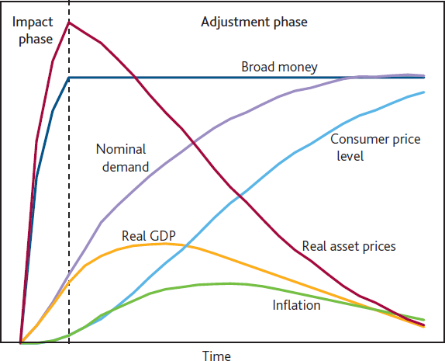However, the effect of QE on the wealth channel cannot last forever. Monetary neutrality means real asset prices are not boosted indefinitely by such policies; their economic effects must ultimately unwind (**Chart 11**).

|  |
| --- |
| **Chart 11: QE wealth effect ultimately temporary** |
| Source: Joyce, M, Tong, M, and Woods, R “The United Kingdom’s quantitative easing policy: design, operation and impact”,  *Bank of England Quarterly Bulletin*, 2011, Q3. |

Said differently, unless an improvement in fundamentals boosts the underlying cash flows of these assets, real valuations will fall back. That structural policies have not boosted real growth sufficiently is a better justification for the re-pricing in risk markets than any loss of confidence in the power of central banks.

Central bank innovation has now extended to negative rates, with around a quarter of global output produced in economies where policy rates are literally through the floor.6

Conceptually the more that effective policy rates can be reduced below equilibrium rates, the better the prospects for demand to grow faster than potential supply, promoting global reflation.

However, it is critical that stimulus measures are structured to boost domestic demand, particularly from sectors of the economy with healthy balance sheets. There are limits to the extent to which negative rates can achieve this.

For example, banks might not pass negative policy rates fully through to their retail customers, shutting off the cash flow and credit channels and thereby limiting the boost to domestic demand.7 That is associated with a commonly expressed concern that negative rates reduce banks’ profitability.

To be clear, monetary policy is conducted to achieve price stability not for the benefit of bank shareholders.

Nonetheless, when negative rates are implemented in ways that insulate retail customers, shutting off the cash flow and other channels that mainly affect domestic demand, while allowing wholesale rates to adjust, their main effect is through the exchange rate channel.

From an individual country’s perspective this might be an attractive route to boost activity. But for the world as a whole, this export of excess saving and transfer of demand weakness elsewhere is ultimately a zero sum game. Moreover, to the extent it pushes greater savings onto the global markets, global short-term equilibrium rates would fall further, pulling the global economy closer to a liquidity trap. At the global zero bound, there is no free lunch.8

For monetary easing to work at a global level it cannot rely on simply moving scarce demand from one country to another. Instead policy needs to increase primarily domestic demand, with the exchange-rate channel more a side effect that accompanies any monetary policy action.

6 Measured at market exchange rates.

7 In some cases household borrowing rates have actually risen.

8 Svensson (2003), “Escaping from a Liquidity Trap and Deflation: The Foolproof Way and Others”, *Journal of Economic Perspectives*, makes the case that exchange rate intervention can help fight deflation in a small open economy.

In any given country, a monetary expansion aimed at boosting domestic demand will tend to reduce effective interest rates9 relative to their equilibrium level, generating an excess of domestic investment over domestic saving that must be met with a capital inflow from abroad.

But viewed from overseas, the corresponding capital outflow will tend to raise the short-term equilibrium rate (**Chart 12**), giving conventional monetary policy overseas more traction.

In this way, the rising tide of global demand would raise all boats.

# Chart 12: Smaller domestic current account (CA) surplus lifts all boats

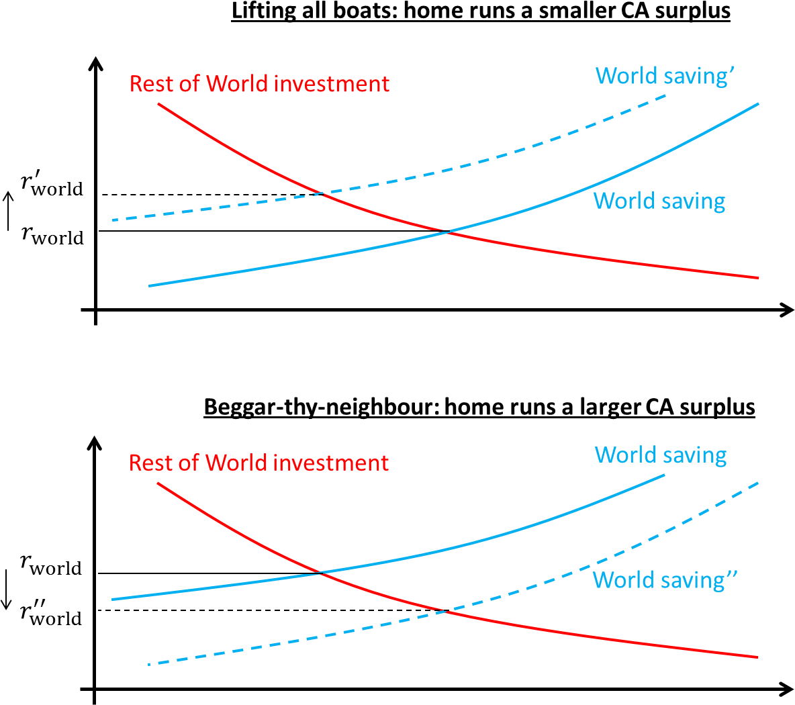

9 That is, interest rates adjusted for the effects of any quantitative or credit easing.

# Wider policy implications

Ultimately, for monetary policy at the zero lower bound to bridge to a better equilibrium, it must be reinforced by other policies. That is, the low interest rate environment puts a premium on domestic and international policy coordination. For example, lower interest rates create space for fiscal policy to boost domestic demand directly, should it be necessary, by lowering the financing cost faced by governments.

And it doesn’t take a genius to recognise that a prolonged period of low interest rates can lead to a build-up of vulnerabilities which could derail an expansion and deepen a subsequent recession.

This means macroprudential policy has an increasingly important role. Rightly, the Chinese G20 Presidency has called for G20 members to learn from each other’s experience of macroprudential management.

The IMF, FSB and BIS will therefore report to G20 Leaders ahead of the Hangzhou Summit regarding processes to analyse systemic risks; toolkits to address vulnerabilities; and mechanisms for domestic and international coordination.

In an increasingly integrated global financial system, this work can help identify areas where we need to work together to keep our systems resilient. It is clear, for example, that strong links exists between asset management in advanced economies and the debt markets relied upon by emerging market corporates.

Where appropriate, the FSB will make policy recommendations regarding structural vulnerabilities associated with asset management activities for public consultation before the Hangzhou Summit. And reinforced by recent experience, the FSB’s second annual report on the effects of reforms will include a comprehensive review of the extent, drivers and likely persistence of any reduction in market liquidity.

# Whither the G20 Plan for Strong, Sustainable, Balanced Growth?

Most fundamentally, the G20 needs to use the time purchased by monetary policy to develop a coherent and urgent approach to supply-side policies.

Gradualism in structural reforms may be promoting disinflationary expectations, while sapping the political process of its mandate. The weakness of investment not only holds back the supply side but also weighs on the equilibrium interest rate and further burdens monetary policy.

At the Brisbane summit in 2014, the G20 leaders agreed an ambitious goal to lift the level of G20 GDP by at least two per cent by 2018.

But only eighteen months on, the *2 in 5 commitments* are starting to look more like the *5/2 diet*.

Less than half of the measures have been implemented, and only around one third of the promised impact on global GDP has been delivered. Moreover, whilst implementation has lagged, the need to boost growth has increased in size and urgency. The Bank of England projects the level of global GDP in 2018 to be over 3% below what the IMF expected at the time of the Brisbane summit.

We need to live up to China’s G20 priorities. Structural reforms with a long-term focus but a short-term implementation horizon. Determined reform of the global architecture for sustainable capital flows. The development of our essential macroprudential frameworks and the implementation of our financial reform commitments to address new vulnerabilities.

These will allow monetary policies to fully bridge to a better future.

# Conclusion

That future needs the arms of macro policy to operate in close concert, domestically and internationally. Demand stimulus alone will not sustainably reflate the global economy. Moreover, sustained low rates could strain the capacities of macroprudential policies.

At their roots, fiscal, monetary, financial and structural policies are deeply complementary, operating through many of the same channels.

A stronger financial system can better channel savings to investment, building demand in the short run and productivity in the long run.

Monetary stimulus is more effective if, in a deflationary environment, other policies can also give households and firms the confidence that global reflation is in prospect.

And structural reforms can boost long-run wealth allowing monetary policy to bring forward spending from future incomes that are real and not ephemeral.

All must recognise the imperative of avoiding the global liquidity trap. Not to beggar-thyself via beggar-thy-neighbour.

Not to obsess over process at the expense of productivity.

But by building resilient domestic demand and sustainable cross border capital flows, we in the G20 can redeem an unforgiving world.

# Annex

**Chart A1: Secular drivers of lower real rates – quantification**

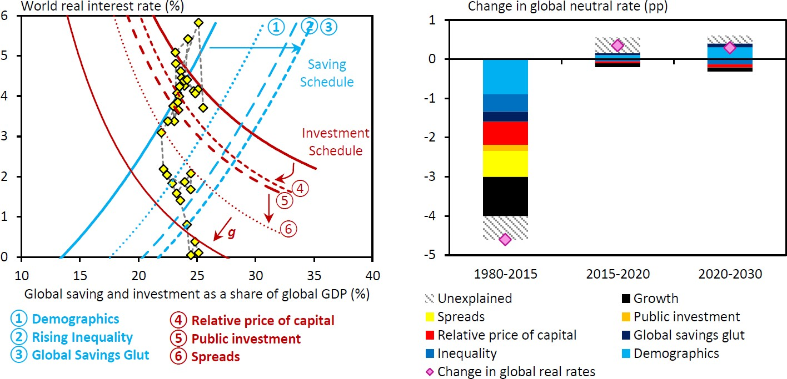

Source: Taken from Rachel and Smith (*ibid*.).